CDH Assistant is an AI powered conversational feature that is integrated with Customer Decision Hub and 1:1 Pega Operations Manager.

To access the CDH Assistant click the Assistant tab and you are directed to the landing page.

From there either you can choose provided topic or you can ask your own customized question.

In portal it will be shown as

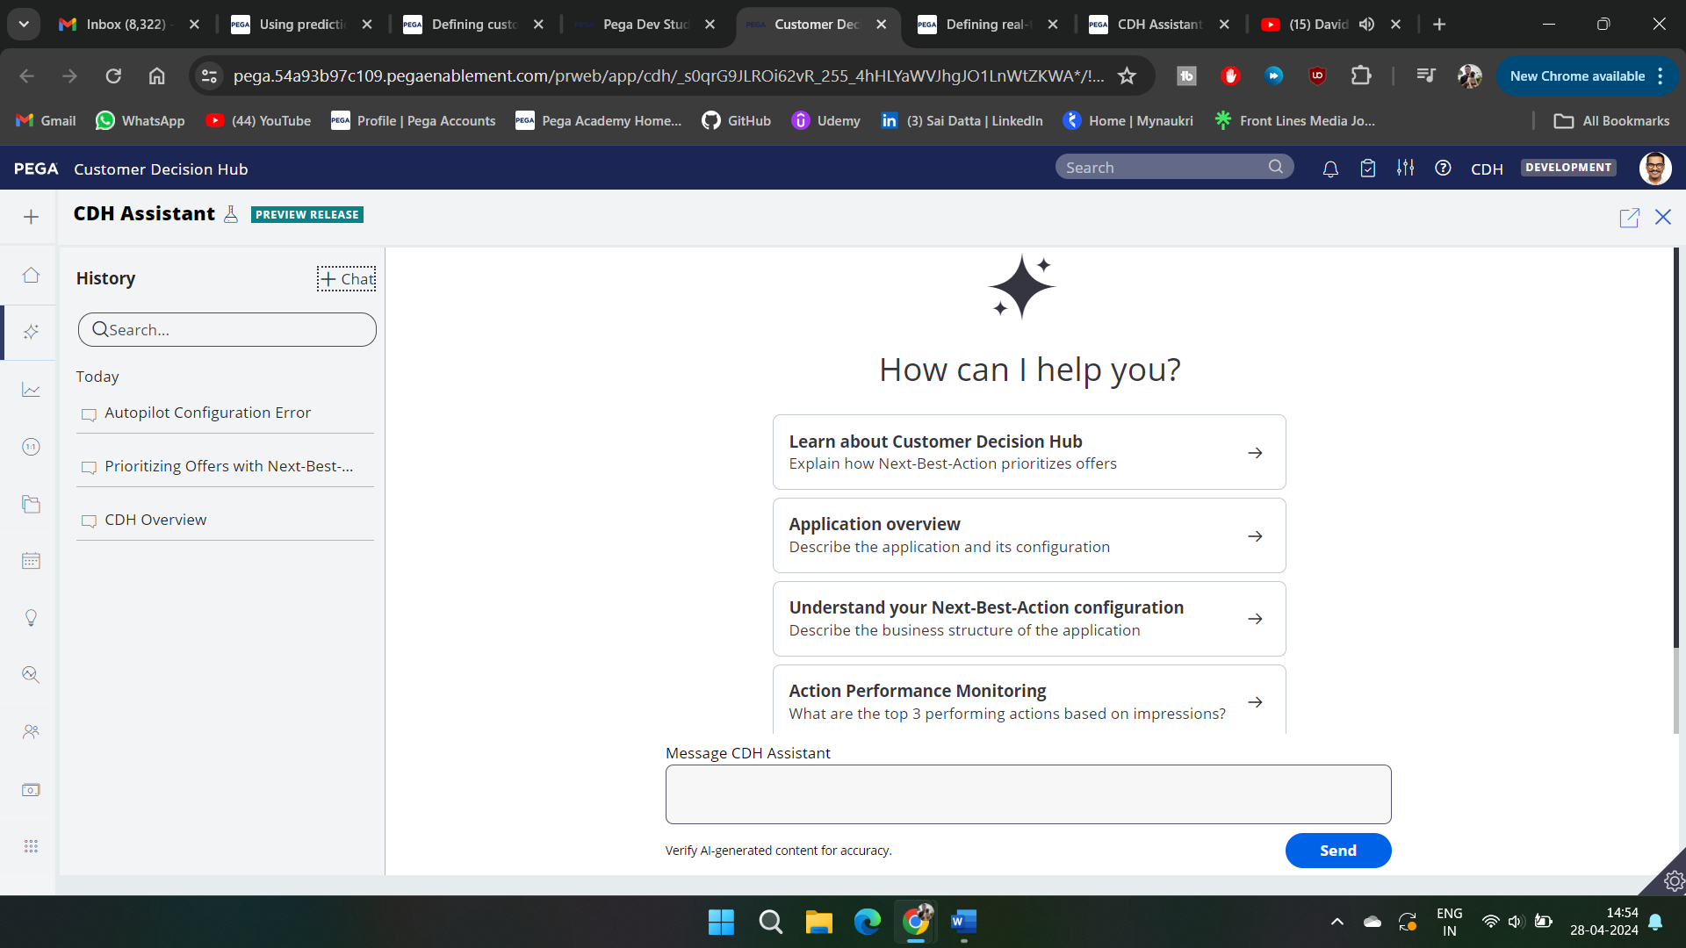

Now in this pre populated are shown

* Learn about CDH
* Application Overview
* Understand your NBA
* Action performance monitoring
* Or just ask(customized question)

And what ever we ask is shown on the left side of the tab

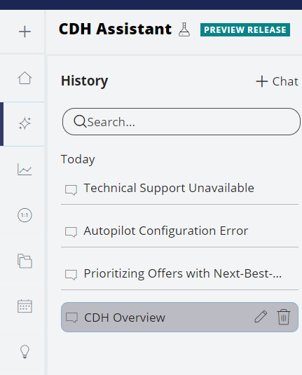

And if asked for overview of the Application it shows as follows

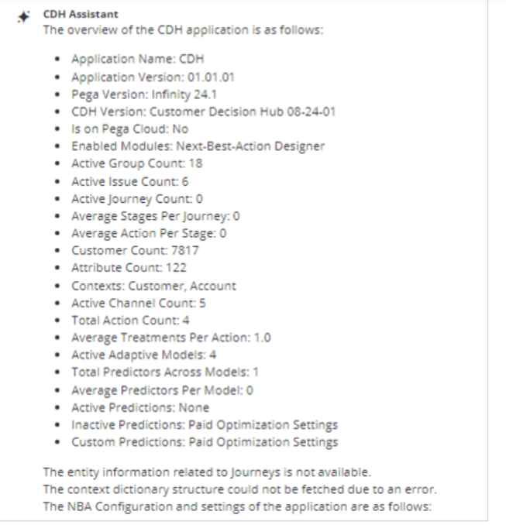

We can seek guidance on installation, implementation set and provide you with the most relevant response, tailored to your needs., together with a link of the knowledge.

You can continue this conversation by asking additional questions also

To keep conversations in order, always start a new chat for a specific concept, feature, or product.

CDH Assistant not only answers questions about the product but also allows you to interact with the documentation by providing links to the relevant sources of knowledge.

Self Study Buddy

Self Study buddy is an intelligent assistant designed to support students in the learning journey, particularly those studying Pega infinity software suite. By using Gen AI technology Self study buddy provides personalized assistance based on Pega Academy and Pega Documentation content.

The primary function of Self Study buddy is to answer technical questions about the Pega infinity software a low code platform for AI powered decisioning and workflow automation. By using AI, self study buddy can understand and respond to a wide range of queries, which provides students with accurate and relevant information to support their learning

One of the key benefits of using Self Study buddy.  The AI technology can quickly and accurately retrieve the relevant information, making the learning process more efficient.

Self-study Buddy and its generative AI technology is a valuable tool for students who want to study Pega Infinity with personalized assistance.

Using Self Study Buddy we can navigate to the top left and click on self study buddy

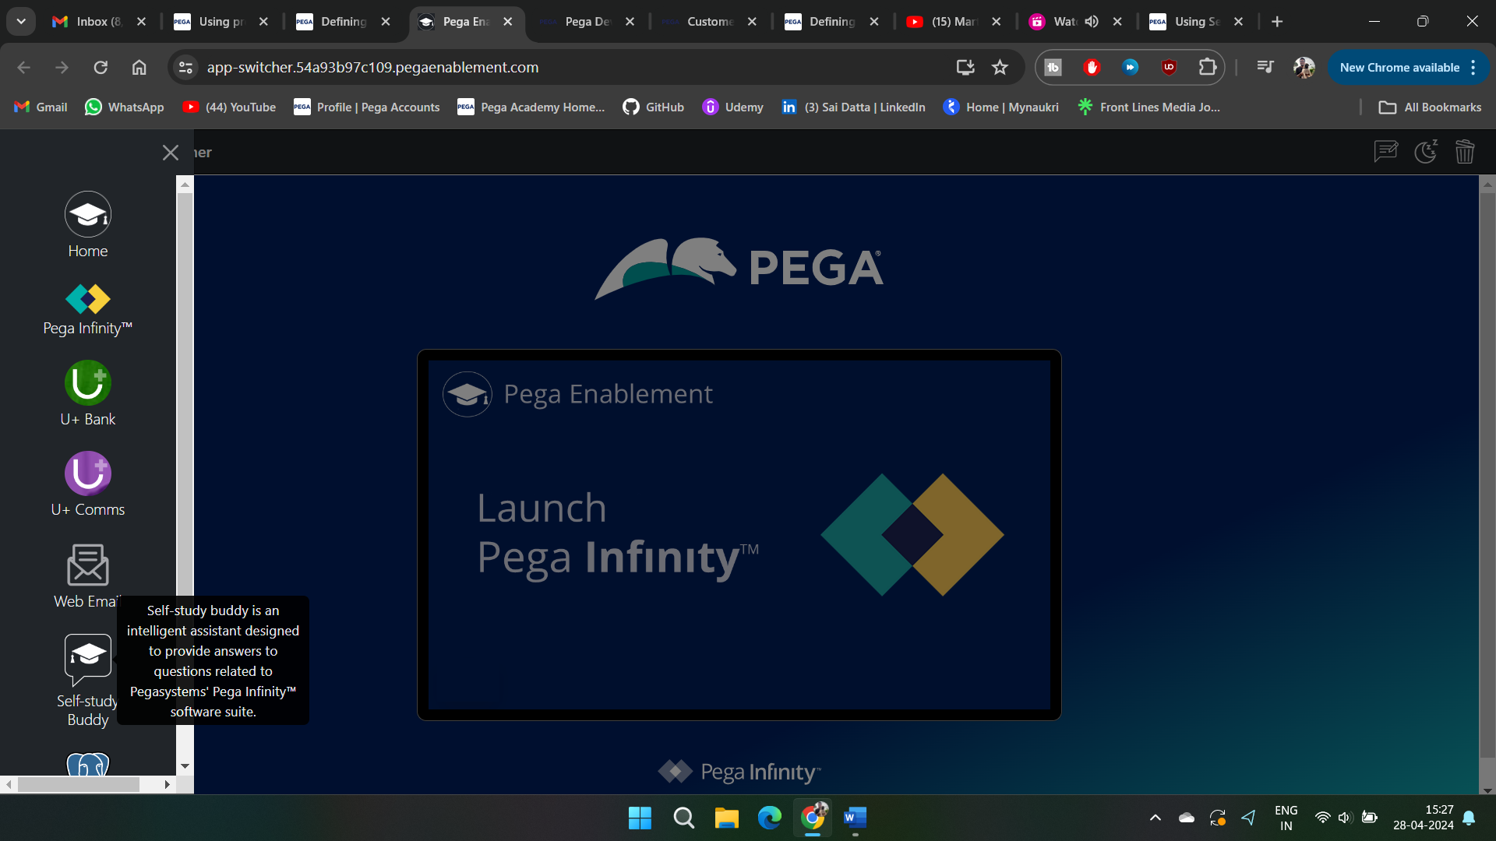

Then if you have account login or else create the account

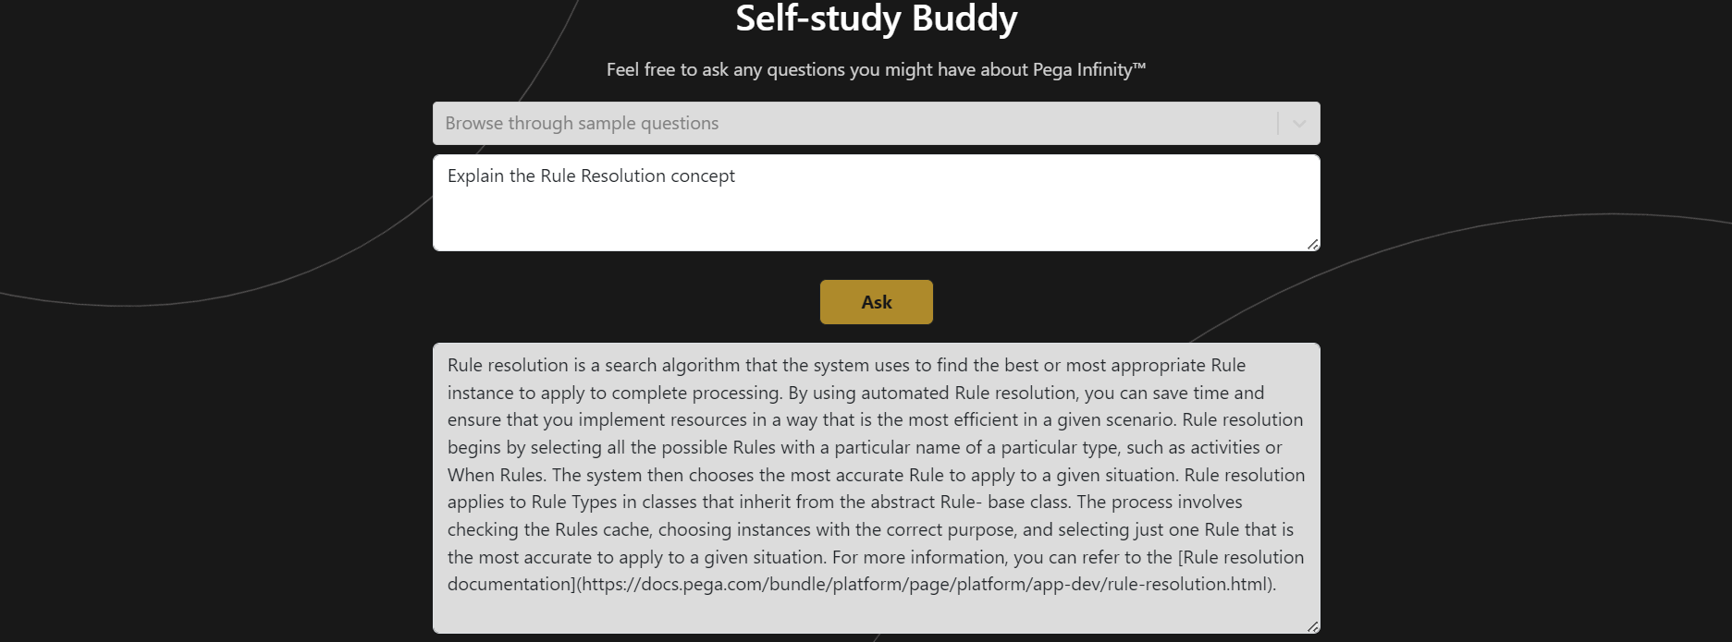

Now we can use this as one of the assistants for the self study buddy.